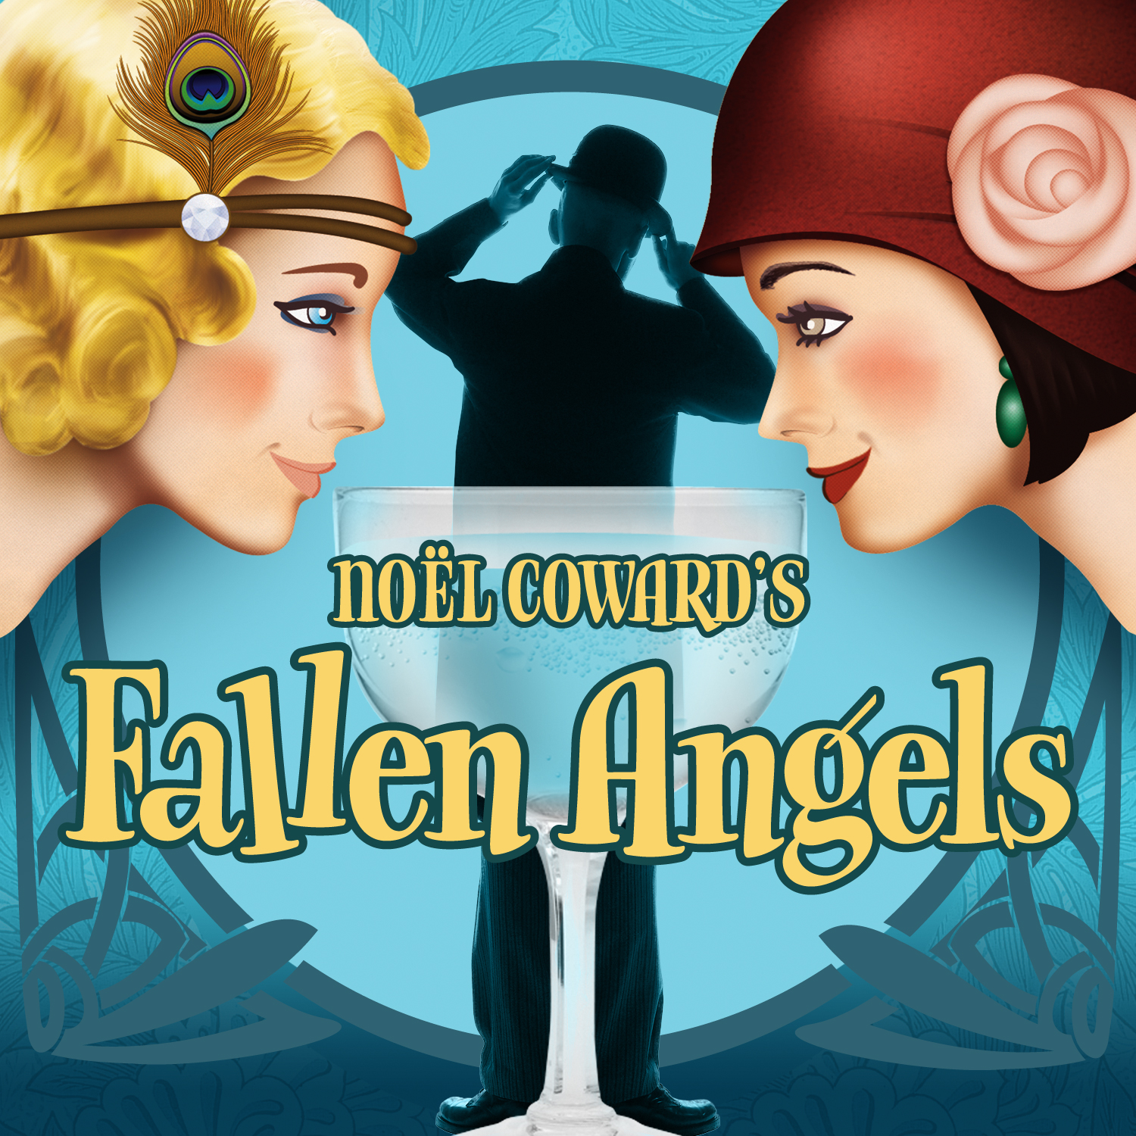
PRESS CONTACT: Nancy Richards – 917-873-6389 (cell)/nancy@northcoastrep.org
MEDIA PAGE: www.northcoastrep.org/press
PHOTOS BY: Aaron Rumley

FOR IMMEDIATE RELEASE, PLEASE:
FALLEN ANGELS PROVIDES TWO HOURS OF FROTHY AND FUN CONFECTION
IN A FAST-PACED COMEDY PRESENTED AT NORTH COAST REP
BY NOËL COWARD
Performances Beginning Wednesday, Sep. 3
With Opening Night, Saturday, September 6, at 8 pm
Running Through Sunday, September 28
Directed by ROSINA REYNOLDS

This is Noël Coward at his inimitable best. FALLEN ANGELS provides a continuously entertaining two hours of sheer delight, combining two slightly bored British women, an amorous Frenchman, clueless husbands and one very cheeky maid. You have the ingredients for an enjoyable evening of merriment that only Noël Coward can provide. When it premiered in 1925, audiences were shocked by its theme of female sexuality and longing. Veering from witty asides to uproarious slapstick, this fast-paced show will leave you in stitches.
Rosina Reynolds will direct a cast that includes Joanna Strapp*, Thomas Stephen Miller, Jackie Ritz*, Jason Maddy*, Summer Spiro*, and Richard Baird*. The design staff includes Marty Burnett (Scenic Design), Matt Novotny (Light Design), Alina Bokovikova (Costume Design), Aaron Rumley (Sound Design), Peter Herman (Hair & Wig Design) comprise the crew. Aaron Rumley* stage manages.
*The actor or stage manager appears through the courtesy of Actors’ Equity Association, the union of professional actors and stage managers in the United States.
This production has been made possible by the generosity of Holly Smith Jones

FALLEN ANGELS previews begin Wednesday, September 3rd. Opening Night on Saturday, September 6th at 8pm includes a post-show reception. There will be a special talkback on Friday, September 12th with the cast and artistic director. It will play Wednesdays at 7pm, Thursdays through Saturdays at 8pm, Saturday and Sunday matinees at 2pm with Sundays at 7pm, through September 28, 2014. (See Schedule below.) North Coast Repertory Theatre is located at 987 Lomas Santa Fe Drive, Ste D, Solana Beach, CA 92075. Tickets: Opening Night - $54, Previews- $37; Week Nights - $44; Sat. Eve. & Sun. Mat.- $48; Sat. Mat. & Sun. Night - $41. Seniors, Students, Military - $3 off admission. Call 858-481-1055 or visit www.northcoastrep.org to purchase tickets.

For background information and photos, go to www.northcoastrep.org/press.
Please follow North Coast Repertory Theatre on social media as well on Facebook at https://www.facebook.com/pages/North-Coast-Rep/128553240497901
Twitter: https://twitter.com/NorthCoastRep
YouTube: http://www.youtube.com/user/NCRTheatre?ob=0
Busy director Rosina Reynolds and her cast members are available for interviews by phone, in person, and in-studio. For more information and to arrange interviews or press tickets, please contact Nancy Richards at nancy@northcoastrep.org, or 917-873-6389 cell.

FACT SHEET

WHAT: NORTH COAST REPERTORY THEATRE presents
FALLEN ANGELS
Written by NOËL COWARD
Directed by Rosina Reynolds

CAST: Joanna Strapp*, Thomas Stephen Miller, Jackie Ritz*, Jason Maddy*, Summer Spiro*, and Richard Baird*

WHERE: North Coast Repertory Theatre
987 Lomas Santa Fe Drive, Ste. D
Solana Beach, CA 92075

SCHEDULE*: Previews: September 3 - 5, 2014
Opens: September 6 @ 8pm
Closes: September 28, 2014
Wed. @ 7pm, Thurs-Sat @ 8PM; Sat & Sun @ 2PM, Sun @7pm
Talkback with cast & director: September 12, 2014

PRICES: Previews $37.00
Opening Night $54.00
Week Nights $44.00
Sat. Matinees & Sunday Nights $41.00
Sat. Nights & Sunday Matinees $48.00

DISCOUNTS: Seniors, Students, Military $3.00 off admission

BOX OFFICE (858) 481-1055 or www.northcoastrep.org

SEPTEMBER
SUN | MON | TUE | WED | THU | FRI | SAT
 |  |  | 3  Preview 8pm | 4  Preview 8pm | 5  Preview 8pm | 6  OPENING  8pm
7  2pm & 7pm | 8 | 9 | 10  7pm | 11  8pm | 12  8pm Talkback | 13  2pm & 8pm
14  2pm & 7pm | 15 | 16 | 17  7pm | 18  8pm | 19  8pm | 20  2pm & 8pm
21  2pm & 7pm | 22 | 23 | 24  7pm | 25  8pm | 26  8pm | 27  2pm & 8pm
28  2pm | 29 | 30

BACKGROUND:
North Coast Repertory Theatre’s 2014-2015 -Season 33 continues with the San Diego Premiere of Freud’s Last Session (October 15 – November 9) follows. Nearing the end of his life, Sigmund Freud has a final visitor, the writer and former atheist C.S. Lewis, who is soon to publish “The Lion, the Witch and the Wardrobe.” Contrasting in styles, Freud is irascible and highly opinionated; Lewis, sunny, warm and unflappable. The result is a lively debate touching on love, religion, politics and life. Mark St. Germain infuses this fictional meeting with gentle humor and sharp dialogue. A must-see for the discerning theatre-lover. This Wonderful Life (December 10 – 28) is the Rep’s holiday gift. James Leaming (“Who Am I This Time?”) returns to North Coast Rep with the San Diego premiere of his dazzling one-man tour-de-force based on the perennial favorite, “It’s a Wonderful Life.” In an amazing display of physical and verbal virtuosity, Leaming brings to life over 32 familiar characters. His Jimmy Stewart-inspired George Bailey leads the impressively portrayed cast of characters from Bedford Falls including Clarence the Angel, Mary, Zuzu and all the colorful townsfolk who rely on him to save them from the greedy Henry Potter. In cities across the nation, Leaming has left audiences cheering. 2015 kicks off with a San Diego musical premiere, Gunmetal Blues (January 14- February 8), a wildly entertaining musical spoof of 1940s film noir laced with mystery, music and demolished dreams. In the best Raymond Chandler tradition, the scene is set in the seedy, smoky Red Eye Lounge, where we meet a tough, trench-coated private eye, blondes and more blondes, henchmen and a jaded piano player who sends up complicated plot concoctions. Fresh, funny and thoroughly inventive, Gunmetal Blues is not to be missed. Neil Simon’s Chapter Two (February 25 - March 22), back by popular demand is the first play ever produced by North Coast Rep, is next on the docket. Based on events in Simon’s life, this charming comedy revolves around the recently widowed George and his neighbor, the recently divorced Jennie. Neither of these bruised souls is eager to reconnect with the opposite sex. Their journey of meeting, dating and forming a relationship is laced with Neil Simon’s golden touch. Romantic, rueful, touching and funny, this play is certain to delight and entertain. The fourth San Diego premiere of the season, Unnecessary Farce (April 15 – May 10), presents the perfect setup for a laugh-filled evening at the theatre. There’s an embezzling mayor, his female accountant who can’t stay dressed, two undercover cops, nefarious hit men, and of course, videotape. This fast-paced farce promises to leave audiences howling with laughter. June brings master playwright Harold Pinter’s Betrayal (June 3 – 28), a play that explores the shifting balance of power within a love triangle. Filled with taut drama and deception, the story unfolds in reverse chronology as the audience takes this treacherous journey with characters who are compelling and brimming with human frailty. Passionate, explosive and surprisingly funny, Betrayal is considered one of Pinter’s most innovative and influential works, one that is certain to provoke lively discussion long after the curtain falls. Season 33 concludes with Side By Side With Sondheim (July 15 – August 9). Revel in the sophistication, wit, insight, heart and genius of Broadway’s most innovative and influential artist, composer-lyricist Stephen Sondheim. Audiences will hear familiar favorites from such shows as Company, Follies, A Little Night Music, A Funny Thing Happened on the Way to The Forum, Westside Story, Gypsy and so many more. An unmatched evening of enchantment for musical theatre fans.

About the North Coast Repertory Theatre
North Coast Repertory Theatre is a professional Equity theatre founded in 1982 by Olive and Tom Blakistone. Currently celebrating its 33rd season, North Coast Rep has received critical acclaim from media and audiences alike, and has evolved into one of the area’s leading performing arts organizations. North Coast Rep prides itself on employing the majority of its actors from Actors’ Equity Association for its high quality, award-winning productions, and staging works by established and emerging playwrights. Throughout its history, North Coast Rep has created a platform where artist and audience thrive through the intimacy of live theatre, recognizing the power of theatre to challenge complacency, revitalize the imagination, nurture the unexpected and embrace the variety and diversity in our lives.

#####

BIOS

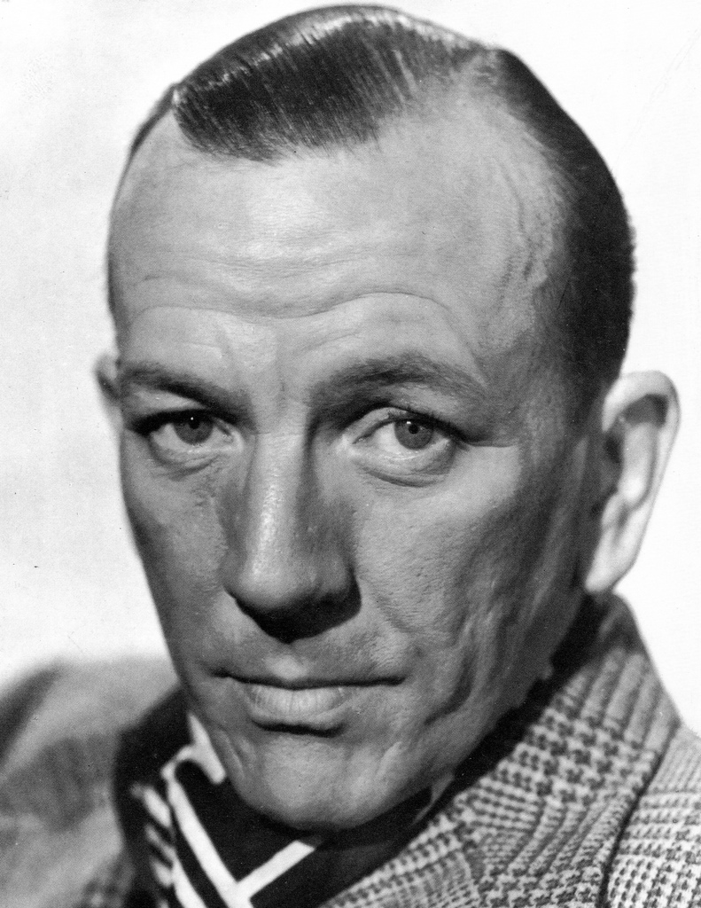
Noël Coward (Playwright), an English playwright, composer, director, actor, and singer, was the epitome and virtual-inventor of 20th century “Englishness” as we know it. He was as much a personality –charming audiences with his wit and style– as he was an artist. Renowned for his extensive index of films, songs, and plays, Coward wrote FALLEN ANGELS in the mid-1920s. FALLEN ANGELS opened in 1925 in London’s Globe Theatre (now known as the Gielgud Theatre), and continued on to Broadway in 1927. Other works include plays such as Blithe Spirit, Private Lives, and Hay Fever, and films such as Brief Encounter, In Which We Serve, and The Italian Job.

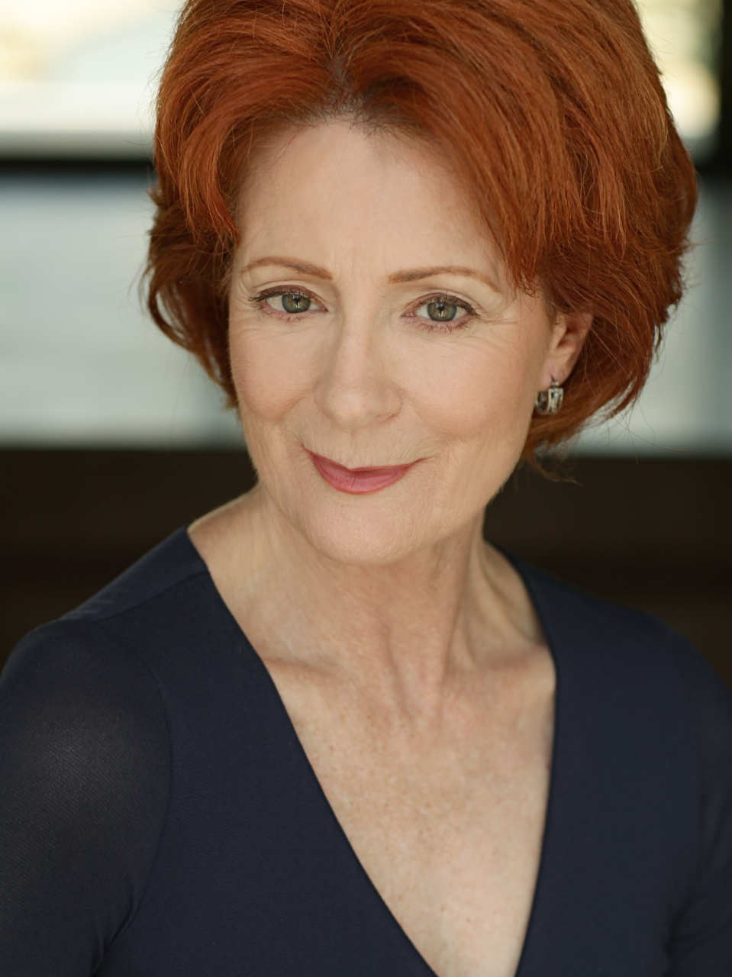
Rosina Reynolds (Director) North Coast Repertory Theatre: Broken Glass; Educating Rita; Glorious; Don’t Dress For Dinner; Relatively Speaking; Importance of Being Earnest; Travesties; An American Daughter; The Sum of Us; Blithe Spirit; Corpse; Rough Crossing; Chekov in Yalta. San Diego Repertory Theatre: Bad Dates. Cygnet Theatre: Atwater, Fixin’ to Die. Renaissance Theatre: Caretaker (San Diego Critics Circle Award). Compass Theatre: Three Days of Rain. Fritz Theatre: Vigil. Hahn Cosmopolitan Theatre: Marvin's Room. Diversionary Theatre: Marriage Bed; Happy Endings are Extra; Twilight of the Golds; Beautiful Thing; Wrinkles; Another American; Asking and Telling; Gross Indecency: The Three Trials of Oscar Wilde; Breaking The Code; Lot's Daughters. Rosina has just returned from Northern Wisconsin, where she directed the Wizard of Oz with 60 kids in 3 weeks, for the Chequamegon Children’s Theatre, which she founded 27 years ago.
This artist is sponsored by Jerry & Jill Hall Charitable Fund at The San Diego Foundation
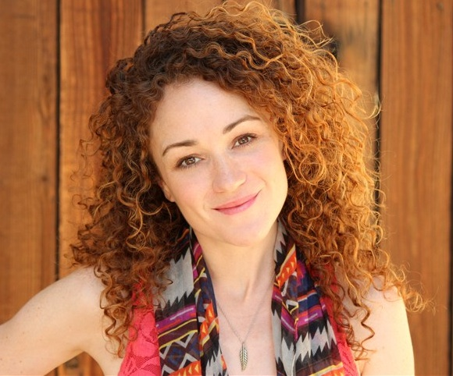
Joanna Strapp* (Julia Sterroll) is very happy to be making her North Coast Rep debut. Regionally, she has performed at The Laguna Playhouse (Steel Magnolias and the World Premiere of The Pursuit of Happiness),The Colony Theatre (I’ll Be Back Before Midnight, Mary’s Wedding), The Rubicon (Noises Off!), The Indian Wells Theater (Trying), as well as the Williamstown Theatre Festival and The Edinburgh Fringe. In Los Angeles, she is a member of The Antaeus Company, where she has performed in The Seagull (2013 LA Weekly Award nomination, Best Supporting Actress), The Liar, Peace In Our Time, Macbeth,The Malcontent and The Curse of Oedipus. Other LA theatre includes The Production Company (In The Next Room or The Vibrator Play, How I Learned to Drive, Mrs. Warren's Profession, Breaking The Code), The Zephyr (Slasher), The StillSpeaking Theatre (The Runner Stumbles). Television includes "House", "The United States of Tara", "Medium", and "Studio 60 On The Sunset Strip". She is a graduate of Carnegie Mellon University's School of Drama. www.JoannaStrapp.com
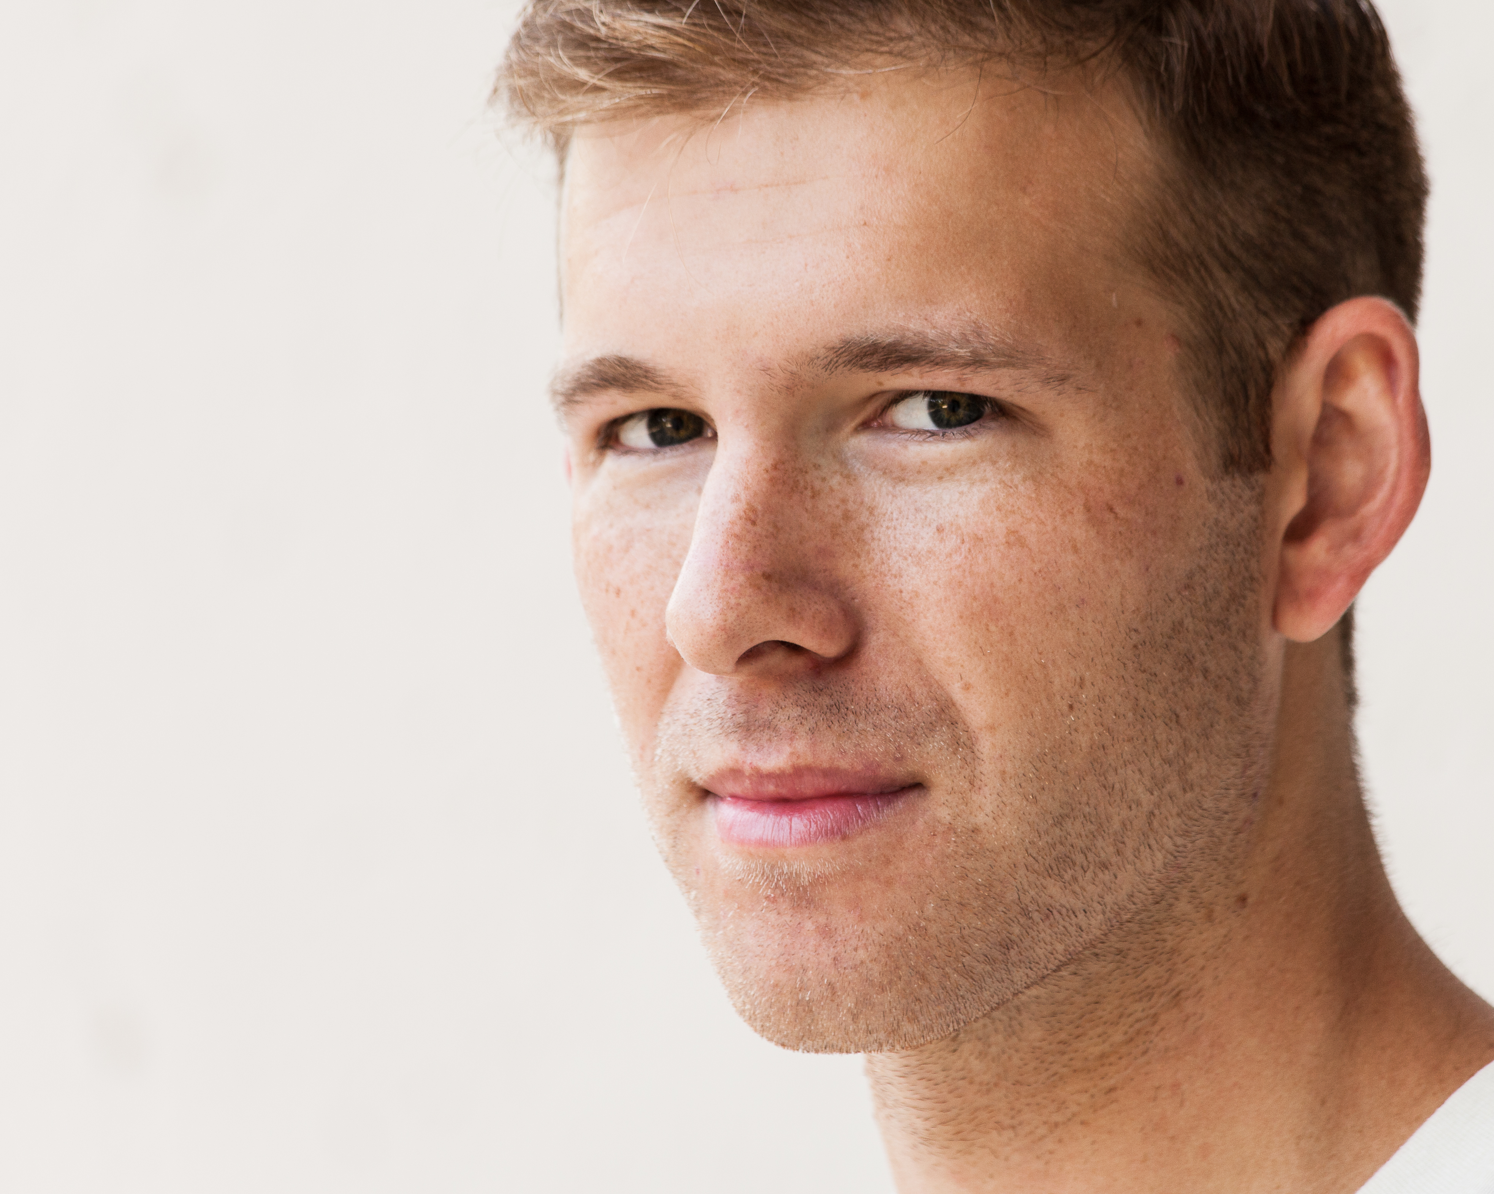
Thomas Stephen Miller (Fred Sterroll) is making his North Coast Rep debut. San Diego theatre credits include: All the Rooms of the House, Macbeth and 'Twas the Night with THE TRIP, Our Town with THE TRIP and La Jolla Playhouse WOW Festival, and The Envelope in the La Jolla Playhouse DNA New Works Series. He was a guest artist in the 40th Anniversary Season of UCSD’s Department of Theatre and Dance, where his work included Seven Against Thebes, Hot L Baltimore, The Dybbuk, and Gas House Baby. He was recently a finalist for the MFA acting programs at NYU Tisch and UCSD. Thomas received his B.A. in Theatre and Political Science: International Relations from UC San Diego.
Thethomasmiller.com thetriptheater.org (check this)
This artist is sponsored by Dori & Jeff Patterson
Jacquelyn Ritz* (Saunders) is delighted to return to North Coast Rep where she played the Lady in last season’s Man with a Load of Mischief. Other San Diego credits include: Titania at Intrepid Shakespeare’s Midsummer Night’s Dream, and directing for the San Diego Fringe Festival. In Chicago, she performed with the Goodman Theatre, Northlight, Royal George, Barto (Shakepeare) Productions, The Apollo, Drury Lane, Marriott Lincolnshire, and Peninsula Players. Regional credits include Bounce at the Kennedy Center (directed by Harold Prince), productions with Milwaukee Repertory, Colorado Shakespeare Festival, Madison Repertory, Asolo Center, and many others. She studied Chekhov (Moscow Art Theatre) and holds an MFA in Acting (Asolo Conservatory). She is a member of SAG/AFTRA. Listen for her as Madame Blueberry and others in VeggieTales cartoons.
This artist is sponsored by Dr. Cynthia & Martin Davis

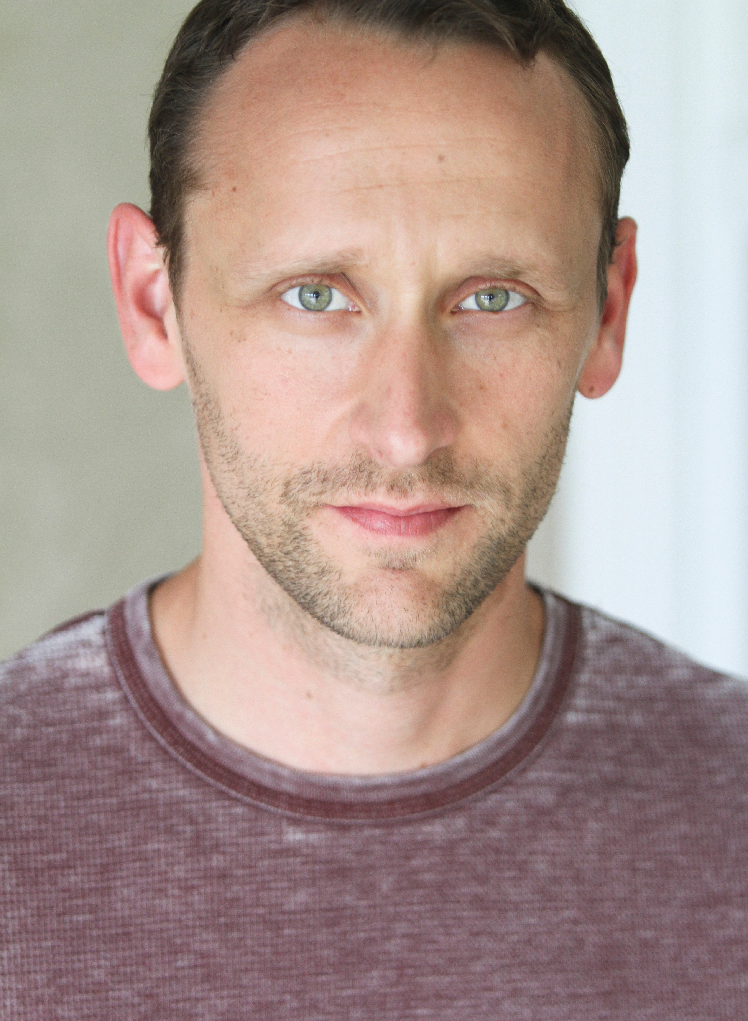
Jason Maddy* (Willie Banbury) San Diego Theatre Credits include roles with: North Coast Repertory Theatre, The Old Globe Theatre, Cygnet Theatre, San Diego Repertory Theatre, Moonlight Stage Productions, Ion Theatre Company, Welk Resort Theatre, San Diego Musical Theater, Premiere Productions, Intrepid Theatre Company and was most recently seen as Orsino in Twelfth Night at Lamb’s Players Theatre. Regional Theatre Credits include: The Utah Shakespearean Festival, Illinois Shakespeare Festival and Kingsmen Shakespeare Festival. Jason holds an MFA from the University of Illinois Urbana -Champaign.
This artist is sponsored by Marti & Adam Rosenberg

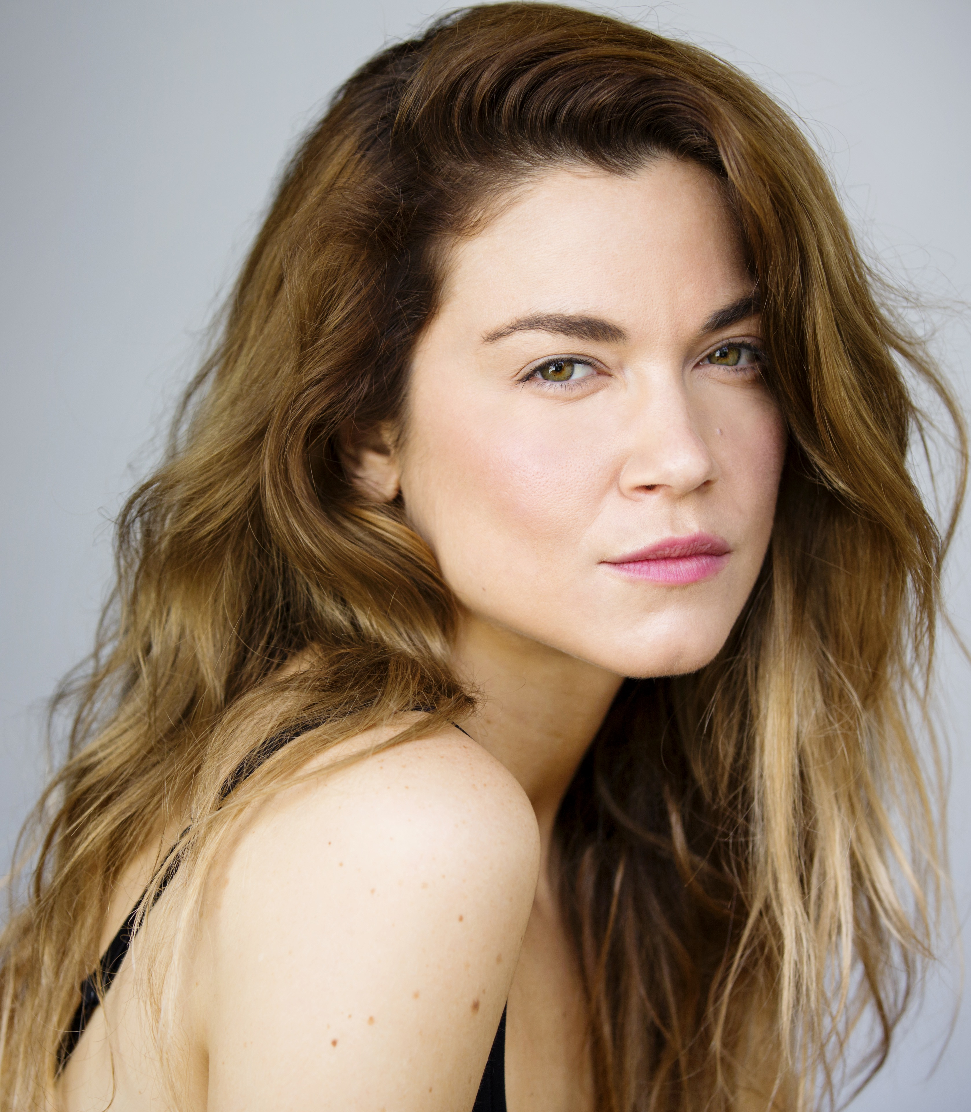
Summer Spiro* (Jane Banbury) This is Summer’s debut at North Coast Rep. She appeared as Sharon in Detroit (San Diego Rep), Jackie in Hay Fever (Moonlight at The Avo) and Celia in As You Like It (Moonlight Amphitheater / New Village Arts) where she was also the musical director. She was nominated for four Irene Ryan Awards at the Kennedy Centers American College Theatre Festival for her performances in Electra, Blithe Spirit, Proposals, and Caucasian Chalk Circle at Mira Costa Theatre. She has since relocated to Los Angeles where she directs/produces short films and music videos and has appeared in a number of independent films. In January, she will play opposite Herbert Siguenza in San Diego Rep's world premiere of Steal Heaven.

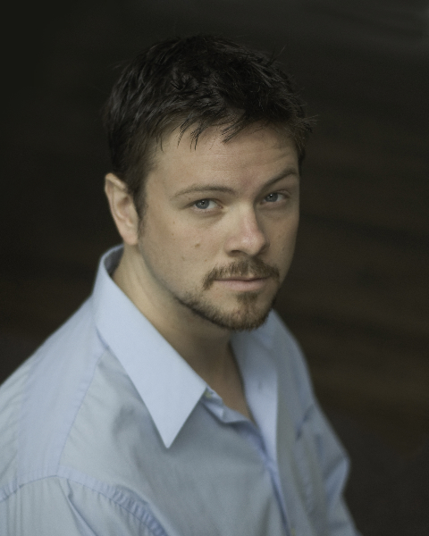
Richard Baird* (Maurice Duclos) is an award winning actor and director and founder of Poor Players Theatre Company. Richard is the Artistic Director of New Fortune Theatre Company which will open its inaugural production of Henry V at Ion Theatre's BLKBOX on Crispin's Day Oct. 25th. Mr. Baird is thrilled to return to North Coast Rep where he has appeared in The School For Lies, Dumb Waiter/Lover, THIS, Romeo and Juliet, Rashomon, Lion In Winter, and more. Regional: The Doll's House (Old Globe Theatre), Midsummer Night's Dream (Portland Center Stage), Cyrano de Bergerac and The Madness of King George (Chicago Shakespeare Theatre), Macbeth and The Winter's Tale (Kingsmen Shakespeare), Oregon Shakespeare Festival, Shakespeare Santa Cruz and many more. Richard served as Associate Artistic Director of Southwest Shakespeare Company where roles included the title roles of Cyrano de Bergerac and Tartuffe, Leontes in the Winter's Tale and Petruchio in Taming of the Shrew. Mr. Baird has directed locally for Intrepid Shakespeare and Diversionary Theatre. Mr. Baird is a proud member of Actor's Equity.
This artist is sponsored by The Jonathan McMurtry Actors Fund

Aaron Rumley* (Stage Manager) North Coast Repertory Theatre: Who Am I This Time; Broken Glass; Two by Pinter: The Lover and the Dumb Waiter, THIS, The Lion in Winter, Heroes, Lend Me A Tenor, My Name is Asher Lev, The Drawer Boy, Becky’s New Car, Voice of the Prairie, Ghosts, Glorious!, Talley’s Folly, Over the Tavern, Rabbit Hole, The Dresser, Don’t Dress for Dinner, Madagascar, Mornings at Seven, String of Pearls, Dracula, Rashomon, Wit, A Moon for the Misbegotten, Leading Ladies, Collected Stories, Halpern & Johnson, Romeo and Juliet, The Bungler, The Chosen, A Life in the Theatre and The Rainmaker. North Carolina Theatre: Talley’s Folly, Picnic, The Miser and On Golden Pond. Aaron received a B.A. in Theatre from the University of North Carolina at Wilmington, and is the production manager at the North Coast Repertory Theatre. Aaron is a Member of Actors’ Equity Association.

Marty Burnett (Resident Scenic Designer) Marty begins his 22nd season as Resident Designer/Technical Director at North Coast Rep. He has designed the last 150 shows. Other venues include Laguna Playhouse, Portland Stage Company, Drury Lane (Chicago), Claridge Hotel (Atlantic City), Union Plaza, Sahara Hotel, Hacienda in
Las Vegas, Coronado Playhouse, Scripps Ranch Theater, Harrah’s Lake Tahoe. Marty is a proud alumni of Creighton University in Omaha, Nebraska.

Matt Novotny (Lighting Design) recently designed the lighting for Romance Romance, Faded Glory, Mandate Memories, The School For Lies, Who Am I This Time?, Broken Glass, Man with a Load of Mischief, Perfect Wedding, Becoming Cuba, The Odd Couple, Time Stands Still, Educating Rita, The Underpants, Dames at Sea, Two by Pinter: The Lover and The Dumb Waiter, THIS, Visiting Mister Green, Lend Me a Tenor, Five Course Love, My Name Is Asher Lev, King O’ the Moon, Ghosts, Glorious, I Love You Because, Old Wicked Songs, Rabbit Hole, Shipwrecked!, The Dresser, Don’t Dress for Dinner, Mornings at Seven, Baby and Rashomon at North Coast Rep. He’s currently the Director of Production for Lyric Opera San Diego. Lighting designs include: Iolanthe, The Merry Widow, The King and I, Countess Maritza, and The Mikado. San Diego: Das Barbecu, The Wiz, West Side Story and Rumors. Regional: Yankee Doodle Dandy (Seattle), Noises Off! (Boston),The Game, (Washington D.C.) and Primal Twang, a guitar concert featuring six Grammy-winning artists. Matthew holds a B.A. in Technical Theatre from San Diego State University, and an M.F.A. from Boston University.

Alina Bokovikova (Costume Design) is thrilled to work with North Coast Repertory Theatre again. Her recent design credits here include: Romance Romance, Mandate Memories, The School For Lies, Broken Glass, Words By, The Underpants, THIS, Henry IV. She has designed about 50 different productions including A Doll’s House (The Old Globe Theatre), References to Salvador Dali Makes Me Hot, A Man, His Wife, and His Hat and A Raisin in a Sun (MOXIE Theatre), The Playwrights Project, Excavating Escondido, Hedda Gabler, Joe Turner’s Come and Gone, Camino Real (Patté Award) (La Jolla Playhouse and UCSD). She loves to experiment with everything: musicals, The Great American Trailer Park Musical, Beehive; film, Stereoblind; the ballet, Les Noces; and opera, La Traviata. Ms. Bokovikova has an M.F.A. in Costume Design from UC San Diego and a Masters Degree in Education from Russia. She is an instructor of costume design at UC San Diego and history of costume at Fashion Institute of Design & Merchandising.
Aaron Rumley (Sound Design)) North Coast Repertory Theatre: Two by Pinter: The Lover and The Dumb Waiter, Visiting Mister Green. Actors Theatre Phoenix: Shipwrecked! An Entertainment. Over a dozen sound designs for the Theatre at North Coast Rep. Aaron received a B.A. in Theatre from the University of North Carolina at Wilmington.

Peter Herman (Hair & Wig Design) has previously designed wigs for over 30 North Coast Rep productions including: Romance Romance, Faded Glory ,Mandate Memories, The School For Lies, Honky Tonk Angels, Travesties, I Love You Because, Little Women, My Name is Asher Lev and Five Course Love. He has also designed costumes for past North Coast Rep productions of 25th Annual Putnam County Spelling Bee, The Big Bang, Madagascar, and Jacques Brel is Alive and Well and Living in Paris. Peter teaches wig and makeup design at San Diego State University. He is glad to be part of the creative team on this show.

Andrea Gutierrez (Production Assistant) Andrea began her career in theater performing in shows including: Guys and Dolls, Fiddler on the Roof and Picnic, before spending several years as a parade performer at Disneyland Resort. Since that time, Andrea has focused on the production side of theater; working in venues including The Old Globe, The La Jolla Playhouse, Starlight Theater and Sea World. Since graduating cum laude from UCLA’s School of Theater, Film & Television in Technical Production and Design, she has been stage managing for youth theaters around San Diego. She is honored to have an opportunity to work with North Coast Rep’s Theatre School, as well as on many of this season’s main stage productions.

John Finkbiner (Scenic Artist) John has been a member of the North Coast Repertory Theatre staff for nearly three years. His favorite shows are Halpern and Johnson, SHIPWRECKED!, The Dresser and Jacques Brel. John received his BA degree at UCLA’s School of Theater, Film and Television in 1991. John is also an accomplished singer/songwriter and performs with his band, the Stereotypes. His music has been featured on Showtime’s “Californication,” Fox’s “Bones” and NBC’s “Knight Rider,” among others. John lives with his wife Judi and his son John Gibson in Leucadia.
#####

